Stages Written by: Striker

(I Got Spurs That) Jingle Jangle Jingle lyrics
Tex Ritter

Yippee yeah, there'll be no wedding bells for today!
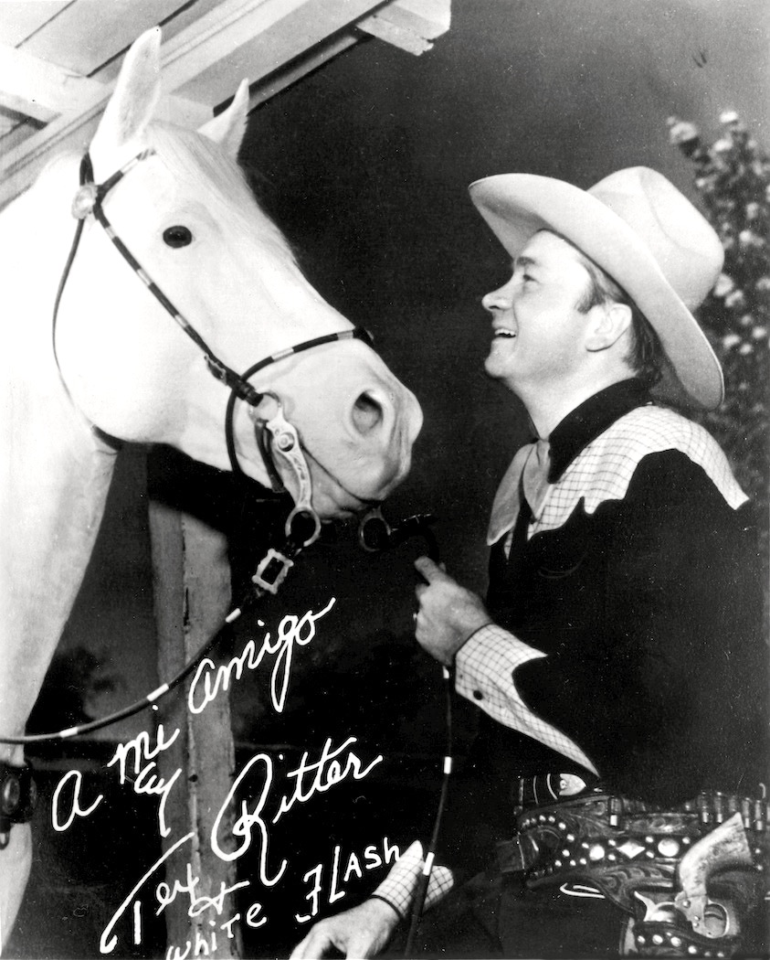
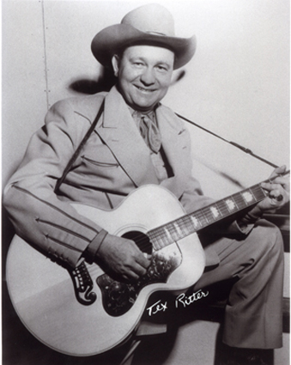
I got spurs that jingle, jangle, jingle
As I go ridin' merrily along
And they sing, 'Oh ain't ya glad you're single'
And that song ain't so very far from wrong

Oh, Lily Bell, oh, Lily Bell,
Though I may have done some foolin, this is why I never fell

I got spurs that jingle, jangle, jingle
As I go ridin' merrily along
And they sing, 'Oh ain't ya glad you're single'
And that song ain't so very far from wrong

Oh, Mary Ann, oh, Mary Ann
Though I've done some moonlight walking this is why I up and went

I got spurs that jingle, jangle, jingle
As I go ridin' merrily along
And they sing, 'Oh ain't ya glad you're single'
And that song ain't so very far from wrong

Oh, Sally Jane, oh, Sally Jane
Though I'd love to stay forever this is why I can't remain

I got spurs that jingle, jangle, jingle
As I go ridin' merrily along
And they sing, 'Oh ain't ya glad you're single'
And that song ain't so very far from wrong

Oh, Bessy Lou, oh, Bessy Lou
Though we've done a heap of dreamin' this is why it won't come true

I got spurs that jingle, jangle, jingle
As I go ridin' merrily along
And they sing, 'Oh ain't ya glad you're single'
And that song ain't so very far from wrong

So I'll go jingling, a-jangling a-jingling along

Cavalier Cowboys – Club Match Rules & Conventions
- Revised 07-26-2015 -

- SASS Rules: All SASS Rules are in affect; unless documented herein, addressed during the Shooter Safety Meeting or specifically stated in the stage directions for a given stage.
- SASS Stage Conventions: All SASS Stage Conventions are in affect; unless specifically stated in the stage directions for a given stage.
- Rank Point Scoring: All Cavalier Cowboys matches will use Rank Point Scoring.
- Safety Officer: Every shooter present is a Safety Officer and has the responsibility to identify, declare and diligently prevent all safety infractions.
- Round Over Berm: A rifle or pistol round over the berm is a Match Disqualification.
- “No Alibi”: All Cavalier Cowboy matches are “no alibi” matches. “Once the first round goes down range, the competitor is committed to the stage and must finish the stage to the best of his or her ability.“
- Ear & Eye Protection: Ear and Eye Protection is mandatory for all shooters and spectators.
- Ground Targets: Targets positioned on/near the ground may only be shoot atd with the shotgun. Ground Targets shoot atd with a rifle or pistol round will result in a Minor Safety Violation.
- Shotgun Knockdown Misses: Unless specifically stated in the stage directions for a given stage and pursuant to SASS rules, all shotgun knockdown targets may be reshoot atd until down, aka “Comstock Rule”.
- Shotgun Shot Size: Shot size must be number 7 lead birdshot or smaller (no steel or plated shot).
- Loading on the Move: Loading on the move is permitted pursuant to SASS rules.
- Drawing on the Move: Drawing on the move is permitted pursuant to SASS rules.
- End of Stage: Unless otherwise directed by a Range Officer, after a stage has been completed the shooter will safely retrieve rifle, shotgun, and pistols and move them to the unloading table. The shooters firearms will not leave the unloading table until they have been verified “cleared” by a Range Officer.
- Coaching: Any shooter who does not want to receive coaching must state their preference at the beginning of each stage. “Proper coaching or no coaching at all is not considered RO Interference and therefore will never be grounds for a reshoot. Improper coaching that either impedes the shooter’s progress or results in a procedural penalty may be grounds for a reshoot.”
- Motorized Vehicles: All motorized vehicles must be operated and parked in designated areas and may not enter pedestrian only areas.
- New Shooters: New Shooters who have never shot a SASS match before must observe one full match prior to shooting their first match, to ensure the shooter is familiar with match procedures and safety requirements. For their very first match, new shooters will be assigned a “mentor”, an experienced SASS shooter, to assist and coach them through the match.

The Spotters Creed:
If you know that it’s a Hit…It’s a Hit
If you know that it’s a Miss…It’s a Miss
If you think it’s a Hit…It’s a Hit
If you think it’s a Miss…IT’S A HIT

Benefit of the doubt always goes to the shooter
STAGE ONE – BAY #2 – Left Side

Round Count: 10 pistol, 10 rifle, and 6+ shotgun

Shooting Order: Rifle, Shotgun, Shotgun, Pistols

Staging: Rifle is loaded with 10 rounds and held with both hands at Position #1. Both pistols are loaded with 5 rounds each and holstered. Shotgun is staged at Position #1.

Procedure: Shooter starts at Position #1 with both hands holding the rifle and when ready says “Jingle, Jangle, Jingle”. At the beep with rifle shoot at the four targets (R1,R2,R3,R4) with a Progressive Sweep for example (R1,R2,R2,R3,R3,R3,R4,R4,R4,R4). Next with shotgun shoot at the four knockdowns (S1,S2,S3,S4) in any order. Move to Position 2. Next with shotgun shoot at the two knockdowns (S5,S6) in any order. Last with pistols shoot at the four targets (P1,P2,P3,P4) using the same instructions as the rifle.

Barrel

Barrel
Position 1
Position 2
21”
t
R1
21”
t
R2
21”
t
R3
21”
t
R4
18”
m
P1

18”
m
P2

18”
m
P3

18”
m
P4

S1

S2

S3

S4

S5

S6

Rifle & Shotgun
Pistols & Shotgun

STAGE TWO – BAY #2 – Left Side

Round Count: 10 pistol, 10 rifle, and 4+ shotgun

Shooting Order: Shooters Choice (Rifle Not Last)

Staging: Rifle is loaded with 10 rounds and staged at Position #2. Both pistols are loaded with 5 rounds each and holstered. Shotgun is staged at Position #2.

Procedure: Shooter has choice of shooting order but the rifle cannot be last. Shooter starts at Position #2 with hands on hips and when ready says “Jingle, Jangle, Jingle”. At the beep: With rifle shoot at the four targets (R1,R2,R3,R4) with double taps and triple taps for 10 rounds and all targets engaged. With shotgun shoot at the four knockdowns (S3,S4,S5,S6) in any order. With pistols shoot at the four targets (P1,P2,P3,P4) using same instructions as the rifle.

Barrel

Barrel
Position 1
Position 2
21”
t
R1
21”
t
R2
21”
t
R3
21”
t
R4
18”
m
P1

18”
m
P2

18”
m
P3

18”
m
P4

S1

S2

S3

S4

S5

S6

Rifle, Pistols & Shotgun

STAGE THREE – BAY #2 – Left Side

Round Count: 10 pistol, 10 rifle, and 4+ shotgun

Shooting Order: Shotgun, Rifle, Pistols

Staging: Rifle is loaded with 10 rounds and staged at Position #1. Both pistols are loaded with 5 rounds each and holstered. Shotgun is staged safely.

Procedure: Shooter starts at Position #1 and when ready says “Jingle, Jangle, Jingle”. At the beep with shotgun shoot at the four knockdowns (S1,S2,S3,S4) in this order: inside, outside, inside, outside. Next with rifle shoot at the four targets (R1,R2,R3,R4) in this order: (R1,R1,R1,R4,R4,R4,R1,R2,R3,R4). Move to Position #2. Last with pistols shoot at the four targets (P1,P2,P3,P4) using the same instructions as the rifle.

Barrel

Barrel
Position 1
Position 2
21”
t
R1
21”
t
R2
21”
t
R3
21”
t
R4
18”
m
P1

18”
m
P2

18”
m
P3

18”
m
P4

S1

S2

S3

S4

S5

S6

Pistols

STAGE FOUR – BAY #2 – Right Side
Rifle & Shotgun

Round Count: 10 pistol, 10 rifle, and 4+ shotgun

Shooting Order: Rifle, Pistols, Shotgun or Rifle, Shotgun, Pistols

Staging: Rifle is loaded with 10 rounds and held at Position #2. Both pistols are loaded with 5 rounds each and holstered. Shotgun is staged safely.

Procedure: Shooter starts at Position #2 holding the rifle at cowboy port arms and when ready says “Jingle, Jangle, Jingle”. At the beep with rifle shoot at the three targets (R1,R2,R3) by alternating 5 rounds between R1 & R2 and then alternating 5 rounds between R3 & R2. Next move to Position #1 or #3 and shoot, then move to the other position and shoot. From Position #1 with pistols shoot at the three targets (P1,P2,P3) using the same instructions as the rifle. From Position #3 with shotgun shoot at the four knockdowns (S1,S2,S3,S4) in any order.

STAGE FIVE – BAY #2 – Right Side
21”
t
R1
21”
t
R2
21”
t
R3
18”
s
P1

18”
s
P2

18”
s
P3

S1

S2

S3

S4

Dead Dog Saloon

Windhorse Stables
STALL #1

STALL #2

Position 1
Position 2
Position 3
Shotgun
Pistols
Rifle

Round Count: 10 pistol, 10 rifle, and 4+ shotgun

Shooting Order: Pistols, Rifle, Shotgun

Staging: Rifle is loaded with 10 rounds and staged safely. Both pistols are loaded with 5 rounds each and holstered. Shotgun is staged safely.

Procedure: Shooter starts at Position #1 and when ready says “Jingle, Jangle, Jingle”. At the beep with pistols shoot at the three targets (P1,P2,P3) with two 1-3-1 sweeps from the same direction, for example (P1,P2,P2,P2,P3, P1,P2,P2,P2,P3). Move to Position #2. Next with rifle shoot at the three targets (R1,R2,R3) using the same instructions as the pistols. Move to Position #3. Last with shotgun shoot at the four knockdowns (S1,S2,S3,S4) in this order: inside, outside, inside, outside.

21”
t
R1
21”
t
R2
21”
t
R3
18”
s
P1

18”
s
P2

18”
s
P3

S1

S2

S3

S4

Dead Dog Saloon

Windhorse Stables
STALL #1

STALL #2

Position 1
Position 2
Position 3
Shotgun
Pistols
Rifle

STAGE SIX – BAY #2 – Right Side

Round Count: 10+1 pistol, 10 rifle, and 4+ shotgun

Shooting Order: Shotgun, Rifle, Pistols

Staging: Rifle is loaded with 10 rounds and staged safely. Both pistols are loaded with 5 rounds each and holstered. Shotgun is staged at Position #3.

Procedure: Shooter starts at Position #3 and when ready says “Jingle, Jangle, Jingle”. At the beep with shotgun shoot at the four knockdowns (S1,S2,S3,S4) in any order. Move to Position #2. Next with rifle shoot at the two targets (R1,R3) with 5 rounds each. Move to Position #1. Next with pistols shoot at the two targets (P1,P3) with 5 rounds each and then shoot at the (P2) target with a pistol reload. Pistol reload may be done any time after the beep.

21”
t
R1
21”
t
R2
21”
t
R3
18”
s
P1

18”
s
P2

18”
s
P3

S1

S2

S3

S4

Dead Dog Saloon

Windhorse Stables
STALL #1

STALL #2

Position 1
Position 2
Position 3
Shotgun
Pistols
Rifle

