*Stages Written by: Striker*

*-- Revised --*

**(I Got Spurs That) Jingle Jangle Jingle lyrics**

**Tex Ritter**

Yippee yeah, there'll be no wedding bells for today!

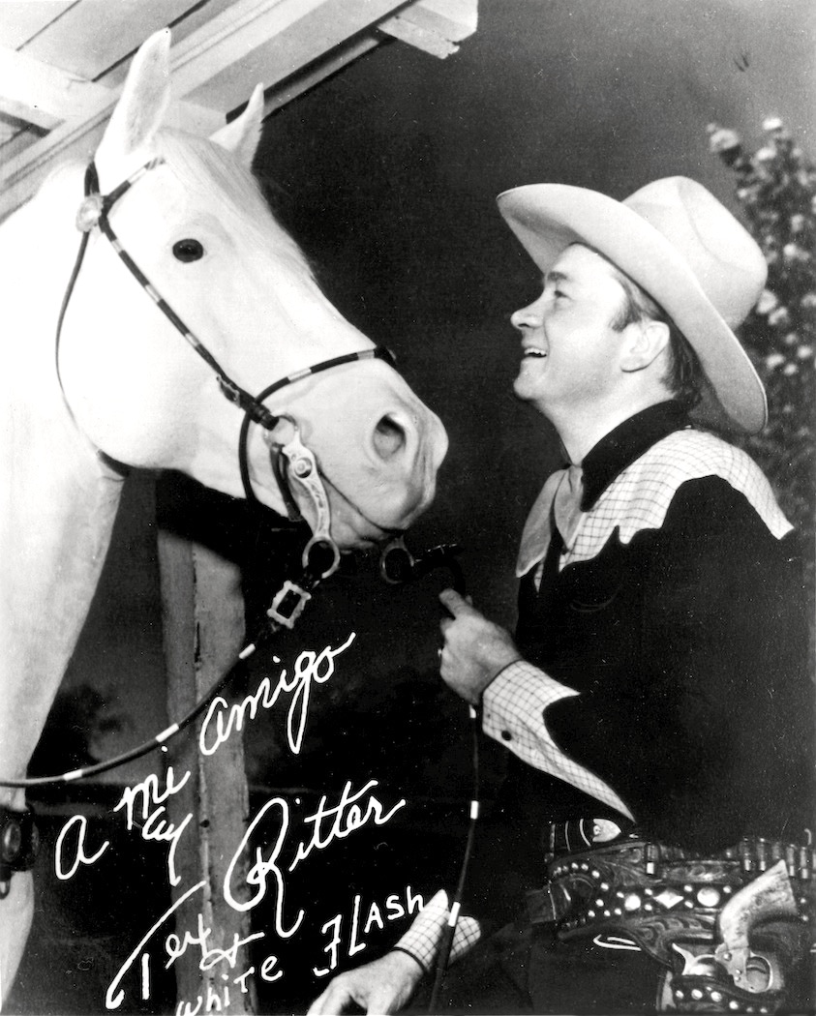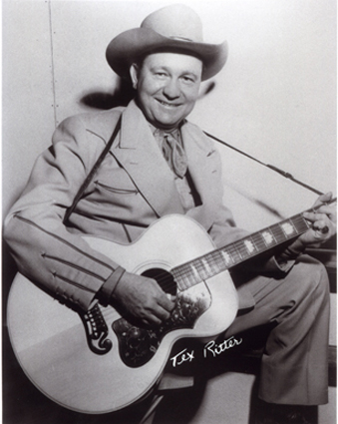

I got spurs that jingle, jangle, jingle

As I go ridin' merrily along

And they sing, 'Oh ain't ya glad you're single'

And that song ain't so very far from wrong

Oh, Lily Bell, oh, Lily Bell,

Though I may have done some foolin, this is why I never fell

I got spurs that jingle, jangle, jingle

As I go ridin' merrily along

And they sing, 'Oh ain't ya glad you're single'

And that song ain't so very far from wrong

Oh, Mary Ann, oh, Mary Ann

Though I've done some moonlight walking this is why I up and went

I got spurs that jingle, jangle, jingle

As I go ridin' merrily along

And they sing, 'Oh ain't ya glad you're single'

And that song ain't so very far from wrong

Oh, Sally Jane, oh, Sally Jane

Though I'd love to stay forever this is why I can't remain

I got spurs that jingle, jangle, jingle

As I go ridin' merrily along

And they sing, 'Oh ain't ya glad you're single'

And that song ain't so very far from wrong

Oh, Bessy Lou, oh, Bessy Lou

Though we've done a heap of dreamin' this is why it won't come true

I got spurs that jingle, jangle, jingle

As I go ridin' merrily along

And they sing, 'Oh ain't ya glad you're single'

And that song ain't so very far from wrong

So I'll go jingling, a-jangling a-jingling along

**STAGE ONE – BAY #2 – Right Side**

**Round Count:** 10 pistol, 10 rifle, and 2+ shotgun

**Shooting Order:** Shotgun, Rifle, Pistols

**Staging:** Rifle is loaded with 10 rounds and staged safely. Both pistols are loaded with 5 rounds each and holstered. Shotgun is staged safely.

**Procedure:** Shooter starts in stall #1 and when ready says “Jingle, Jangle, Jingle”. At the beep with shotgun engage the two knockdown targets (S1, S2) in any order. Move to stall #2. Next with rifle engage the three rifle targets (R1, R2, R3) in the following order (R1, R1, R2, R2, R2, R3, R3, R2, R2, R2). Last with pistols engage the three pistol targets (P1, P2, P3) using the same instructions as the rifle.

Windhorse Stables

**STALL #1**

**STALL #2**

Dead Dog Saloon

**Shotgun**

**Rifle & Pistols**

21”

t

**R1**

21”

m

**R2**

21”

t

**R3**



**P1**



**P2**



**P3**

**S1**

**S2**

21”

t

**R4**

21”

t

**R5**

21”

t

**R6**

21”

t

**R7**

s

**P4**

s

**P5**

s

**P6**

s

**P7**

**S3**

**S4**

**S5**

**S6**

## STAGE TWO – BAY #2 – Right Side

**Round Count:** 10 pistol, 10 rifle, and 4+ shotgun

**Shooting Order:** Rifle, Pistols, Shotgun

**Staging:** Rifle is loaded with 10 rounds and staged safely. Both pistols are loaded with 5 rounds each and holstered. Shotgun is staged safely.

**Procedure:** Shooter starts in stall #2 with hands above shoulders and when ready says “Jingle, Jangle, Jingle”. At the beep with pistols engage the three pistol targets (P1, P2, P3) in a Double Tap Nevada Sweep starting on the middle (P2) target, for example (P2, P2, P1, P1, P2, P2, P3, P3, P2, P2). Next with rifle engage the three rifle targets (R1, R2, R3) using the same instructions as the pistols. Move to the left window. Next with shotgun engage the two knockdown targets (S3, S4) in any order. Move to the right window. Last with shotgun engage the two knockdown targets (S5, S6) in any order.

Windhorse Stables

**STALL #1**

**STALL #2**

Dead Dog Saloon

**Rifle & Pistols**

21”

t

**R1**

21”

m

**R2**

21”

t

**R3**



**P1**



**P2**



**P3**

**S1**

**S2**

21”

t

**R4**

21”

t

**R5**

21”

t

**R6**

21”

t

**R7**

s

**P4**

s

**P5**

s

**P6**

s

**P7**

**S3**

**S4**

**S5**

**S6**

## STAGE THREE – BAY #2 – Right Side

**Shotgun**

**Shotgun**

**Round Count:** 10 pistol, 10 rifle, and 2+ shotgun

**Shooting Order:** Rifle, Shotgun, Pistols

**Staging:** Rifle is loaded with 10 rounds and staged safely. Both pistols are loaded with 5 rounds each and holstered. Shotgun is staged safely.

**Procedure:** Shooter starts in the doorway with hands on door frame and when ready says “Jingle, Jangle, Jingle”. At the beep with rifle engage the four rifle targets (R4, R5, R6, R7) in a Progressive Sweep, for example (R4, R5, R5, R6, R6, R6, R7, R7, R7, R7). Next move to either the left or right window. At a window with shotgun engage the two knockdown targets (S3, S4 or S5, S6) in any order. Move to the doorway. Last with pistols engage the four pistol targets (P4, P5, P6, P7) using the same instructions as the rifle.

Windhorse Stables

**STALL #1**

**STALL #2**

Dead Dog Saloon

21”

t

**R1**

21”

m

**R2**

21”

t

**R3**



**P1**



**P2**



**P3**

**S1**

**S2**

21”

t

**R4**

21”

t

**R5**

21”

t

**R6**

21”

t

**R7**

s

**P4**

s

**P5**

s

**P6**

s

**P7**

**S3**

**S4**

**S5**

**S6**

## STAGE FOUR – BAY #2 – Right Side

**Rifle & Pistols**

**Shotgun**

**Shotgun**

**Round Count:** 10 pistol, 10 rifle, and 4+ shotgun

**Shooting Order:** Shotgun, Shotgun, Rifle, Pistols

**Staging:** Rifle is loaded with 10 rounds and staged safely. Both pistols are loaded with 5 rounds each and holstered. Shotgun is staged safely.

**Procedure:** Shooter starts at the right window and when ready says “Jingle, Jangle, Jingle”. At the beep with shotgun engage the two knockdown targets (S5, S6) in any order. Move to the left window. Next with shotgun engage the two knockdown targets (S3, S4) in any order. Move to stall #2. Next with rifle engage the (R2) rifle target in a Texas Sweep, for example (R2, R2, R2, R2, R2, R2, R2, R2, R2, R2). Last with pistols engage the (P2) pistol targets using the same instructions as the rifle.

## STAGE FIVE – BAY #2 – Right Side

**Shotgun**

**Shotgun**

Windhorse Stables

**STALL #1**

**STALL #2**

Dead Dog Saloon

**Rifle & Pistols**

21”

t

**R1**

21”

m

**R2**

21”

t

**R3**



**P1**



**P2**



**P3**

**S1**

**S2**

21”

t

**R4**

21”

t

**R5**

21”

t

**R6**

21”

t

**R7**

s

**P4**

s

**P5**

s

**P6**

s

**P7**

**S3**

**S4**

**S5**

**S6**

**Round Count:** 10 pistol, 10 rifle, and 4+ shotgun

**Shooting Order:** Shotgun, Rifle, Pistols, Shotgun

**Staging:** Rifle is loaded with 10 rounds and staged safely. Both pistols are loaded with 5 rounds each and holstered. Shotgun is staged safely.

**Procedure:** Shooter starts at the left window with hands on shotgun and when ready says “Jingle, Jangle, Jingle”. At the beep with shotgun engage the two knockdown targets (S3, S4) in any order. Move to the doorway. Next with rifle engage the four rifle targets (R4, R5, R6, R7) in the following order (R4, R7, R4, R7, R4, R7, R5, R6, R5, R6). Next with pistols engage the four pistol targets (P4, P5, P6, P7) using the same instructions as the rifle. Next move to the right window. Last with shotgun engage the two knockdown targets (S5, S6) in any order.

Windhorse Stables

**STALL #1**

**STALL #2**

Dead Dog Saloon

21”

t

**R1**

21”

m

**R2**

21”

t

**R3**



**P1**



**P2**



**P3**

**S1**

**S2**

21”

t

**R4**

21”

t

**R5**

21”

t

**R6**

21”

t

**R7**

s

**P4**

s

**P5**

s

**P6**

s

**P7**

**S3**

**S4**

**S5**

**S6**

## STAGE SIX – BAY #2 – Right Side

**Shotgun**

**Shotgun**

**Rifle & Pistols**

**Round Count:** 10 pistol, 10 rifle, and 2+ shotgun

**Shooting Order:** Rifle, Pistol, Pistol, Shotgun

**Staging:** Rifle is loaded with 10 rounds and held at cowboy port arms. Both pistols are loaded with 5 rounds each and holstered. Shotgun is staged safely.

**Procedure:** Shooter starts at the right window with rifle at cowboy port arms and when ready says “Jingle, Jangle, Jingle”. At the beep with rifle engage the two rifle targets (R6, R7) by alternating 10 rounds between them, for example (R6, R7, R6, R7, R6, R7, R6, R7, R6, R7). Next with pistols engage the two pistol targets (P6, P7) by alternating 5 rounds between them. Move to the left window. Next with pistols engage the two pistol targets (P4, P5) by alternating 5 rounds between them. Last with shotgun engage the two knockdown targets (S3, S4) in any order.

Windhorse Stables

**STALL #1**

**STALL #2**

Dead Dog Saloon

21”

t

**R1**

21”

m

**R2**

21”

t

**R3**



**P1**



**P2**



**P3**

**S1**

**S2**

21”

t

**R4**

21”

t

**R5**

21”

t

**R6**

21”

t

**R7**

s

**P4**

s

**P5**

s

**P6**

s

**P7**

**S3**

**S4**

**S5**

**S6**

**Shotgun & Pistols**

**Rifle & Pistols**