Cavalier Cowboys
July 6, 2014
By: BS Walker

You drift on into the town of Kubaville located in Cavalier County ‘cause you heard from an old prospector, Prairie City Slim there was a Circus in town. You figure to surprise your favorite gal, Miss Jane with tickets to the show but when you get to the ticket booth, it’s closed. So you walk into the main tent, walk up behind the ring master and tap him on the shoulder. You’re goanna get your tickets come hell or high water. To your amazement its Windhorse Rider, the drunk that always hung out at Kate’s Place is now the circus ringmaster. You would of thought he’d been hung by now. Anyway, he tells you the show is canceled ‘cause that rotten outlaw Swifty McDraw had stolen their cash box and the sheriff won’t do anything about it. Seems Swifty must know of a secret watering hole because he always makes his escape by heading out into the desert , the posse always runs out of water and must turn back, so the sheriff just doesn’t bother anymore. Being raised by Indians, they had shown you their secret watering hole, Chug a Lug Rock many years ago. It seems you are not the only white man that knows where it’s at. You tell Windhorse Rider you will get his money back for free tickets and the use of a Camel, and he agrees. Knowing that Swifty’s horse will have to rest several times in the desert heat and the Camel won’t, you make it to Chug a Lug Rock before Swifty McDraw and hide. You don’t wait long when here he comes walking his horse behind him up to the secret watering hole. At that point you step out from behind a rock with guns in hand and tell Swifty “You Can Lead Your Horse to Water, But You’ll Get Lead” (led).

Cavalier Cowboys
July 6

LEFT BAY
Stage: 1
Round Count: 10-Pistol, 10-Rifle, 4 + Shotgun
Shooting Order: Rifle, Shotgun, Pistol
Staging: Pistols loaded with 5 rounds each, holstered, Rifle loaded with 10 rounds on the horse, Shotgun also on the horse.
Procedure: Shooter starts standing at the horse with both hands touching the horse and when ready says “YOU’LL GET LEAD”. At the beep with rifle engage the rifle targets R1, R2, R3 starting from either end, with a 1, 3, 1 sweep and repeat from the same direction (ex. R1, R2, R2, R2, R3, R1, R2, R2, R2, R3). Next with shotgun engage S1, S2, knockdowns any order, move with safe shotgun to table and engage S3, S4 knockdowns any order. Last with pistols engage the pistol targets P1, P2, P3, with the same instructions as the rifle.

Stage: 2
Round Count: 10-Pistol, 10-Rifle, 4 + Shotgun
Shooting Order: Any order but Rifle can’t be last
Staging: Pistols loaded with 5 rounds each, on the table, Rifle loaded with 10 rounds on the table, Shotgun also on the table.
Procedure: Shooter starts at the table with both hands on the table. When ready say, “YOU’LL GET LEAD” and at the beep starting with any gun and rifle can’t be last, with shotgun engage S1, S2, S3, S4 knockdowns any order, with rifle engage the outside 2 rifle targets R1, and R3 by alternating for 10 rounds and with the pistols alternate for 10 rounds on the outside 2 pistol targets P1,and P3. Pistols returned to table.

Cavalier Cowboys
July 6

Stage: 3
Round Count: 10-Pistol, 10-Rifle, 2 + Shotgun
Shooting Order: Pistol, Rifle, Shotgun
Staging: Pistols loaded with 5 rounds each, holstered, Rifle loaded with 10 rounds on the table, Shotgun staged safely.
Procedure: Start standing behind table with hands at your sides and say “YOU’LL GET LEAD”. At the beep with pistols engage the pistol targets P1, P2, P3 from the left with a 2, 1, 2 sweep and repeat (ex. P1, P1, P2, P3, P3, P1, P1, P2, P3, P3). Then with rifle engage the rifle targets R1, R2, R3 the same as with pistols. Last move behind horse and with shotgun engage S1 and S2 knockdowns any order.
Stages 1, 2, 3
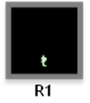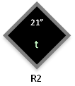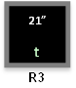

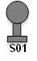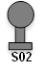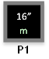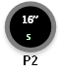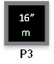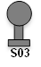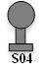

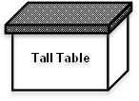
Cavalier Cowboys
July 6
RIGHT BAY:
Stage 4:
Round Count: 10-Pistol, 10-Rifle, 4 + Shotgun
Shooting Order: Rifle, Shotgun, Pistol
Staging: Pistols loaded with 5 rounds each, holstered, Rifle loaded with 10 rounds in saloon doorway, Shotgun staged safely.
Procedure: Shooter starts in saloon doorway with both hands on doorframe. When ready say “YOU’LL GET LEAD” then at the beep with rifle engage the rifle targets R1, R2, R3, R4, starting at either end with a 3, 2, 2, 3, sweep(ex. R1, R1, R1, R2, R2, R3, R3, R4, R4, R4). Move to the left window and with shotgun engage the 4 knockdowns S3, S4, S5, S6, in any order. Move back to the doorway and with pistols engage the pistol targets P3, P4, P5, P6, with the same instructions as the rifle.

Stage 5:
Round Count: 10-Pistol, 10-Rifle, 2 + Shotgun
Shooting Order: Rifle, Pistol, Shotgun
Staging: Pistols loaded with 5 rounds each, holstered, Rifle loaded with 10 rounds from barrel at Cowboy Port Arms, Shotgun in bay 2.
Procedure: Start standing at barrel with rifle at Cowboy Port Arms and say “YOU’LL GET LEAD”. At the beep with rifle engage the left 2 rifle targets R1, R2, from the left with a progressive sweep on the 2 targets (ex. R1, R2, R2, R1, R1, R1, R2, R2, R2, R2). Move to bay 2 of the Livery and with pistols engage the 2 pistol targets P1, P2, the same as with rifle. Last with shotgun engage S1, S2, knockdowns in any order.

Cavalier Cowboys
July 6
Stage: 6
Round Count: 10-Pistol, 10-Rifle, 4 + Shotgun
Shooting Order: Shotgun, Rifle, Pistol
Staging: Pistols loaded with 5 rounds each, holstered, Rifle loaded with 10 rounds in left window, shotgun in left window.
Procedure: Start standing at left window with hands touching hat, head and when ready say “YOU’LL GET LEAD”. At the beep with shotgun engage the 4 shotgun knockdowns S3, S4, S5, S6, in any order. With rifle from window engage the 4 rifle targets R1, R2, R3, R4, starting from either end with a Nevada sweep (ex. R1, R2, R3, R4, R3, R2, R1, R2, R3, R4 ). Move to doorway and with pistols engage pistol targets P3, P4, P5, P6, exactly as you did with the rifle.
Stages: 4, 5, 6

”
R2
t

”
R3
t

”
R4
t

”
R1
t

S05

S03

S04

S06

S01

S02

16”
P6
m
16”
P5
m
16”
P4
m
16”
P3
m
16”
P1
m
16”
P2
m

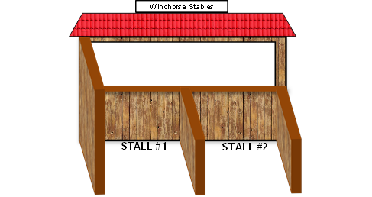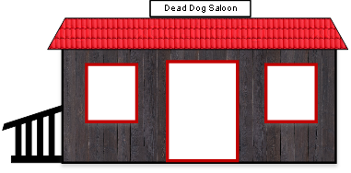

Barrel

